Q1. C program to demonstrate the working of fork() system call

Source Code:

#include <stdio.h>

#include <unistd.h>

int main() {

pid_t pid;

printf("Before fork()\n");

pid = fork();

if (pid == 0) {

printf("Child process: PID = %d\n", getpid());

} else if (pid > 0) {

printf("Parent process: PID = %d, Child PID = %d\n", getpid(), pid);

} else {

printf("Fork failed\n");

return 1;

}

printf("After fork()\n");

return 0;

}

Output:

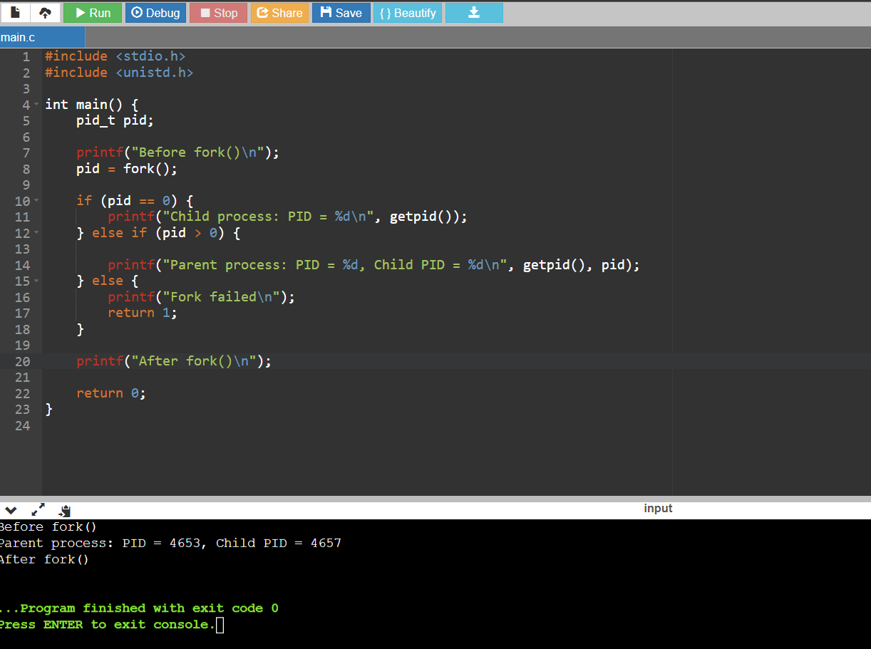

Q2. C program in which parent process computes the SUM OF ODD NUMBERS and child process computes the sum of EVEN NUMBERS stored in array using fork().

Source Code:

#include <stdio.h>

#include <stdlib.h>

#include <unistd.h>

#define ARRAY_SIZE 10

int main() {

int arr[ARRAY_SIZE];

int sum_even = 0, sum_odd = 0;

printf("Enter %d elements for the array:\n", ARRAY_SIZE);

for (int i = 0; i < ARRAY_SIZE; i++) {

printf("Enter element %d: ", i + 1);

scanf("%d", &arr[i]);

}

pid_t pid = fork();

if (pid == 0) {

for (int i = 0; i < ARRAY_SIZE; i++) {

if (arr[i] % 2 == 0)

sum_even += arr[i];

}

printf("Child process: Sum of even numbers = %d\n", sum_even);

} else if (pid > 0) {

for (int i = 0; i < ARRAY_SIZE; i++) {

if (arr[i] % 2 != 0)

sum_odd += arr[i];

}

printf("Parent process: Sum of odd numbers = %d\n", sum_odd);

} else {

printf("Fork failed\n");

return 1;

}

return 0;

}

Output:

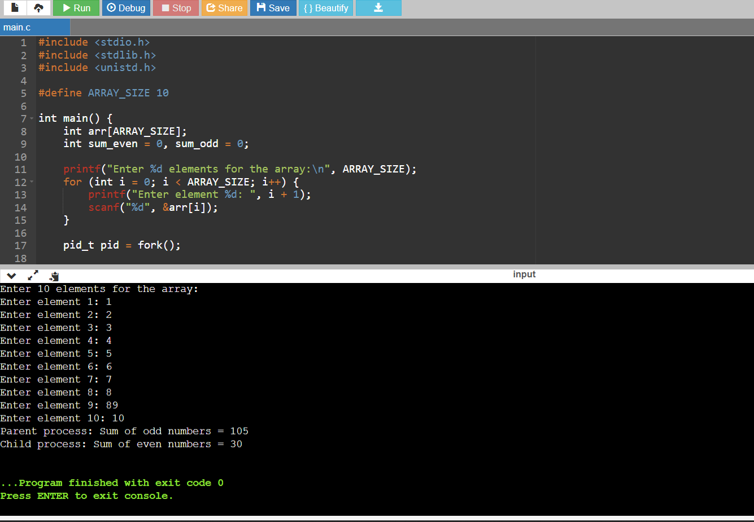

Q3.C program to implement the Zombie process

Source code:

#include <stdio.h>

#include <stdlib.h>

#include <unistd.h>

int main() {

pid_t pid = fork();

if (pid < 0) {

perror("Fork failed");

exit(EXIT_FAILURE);

} else if (pid == 0) {

printf("Child process created, PID = %d\n", getpid());

exit(EXIT_SUCCESS);

} else {

printf("Parent process, PID = %d\n", getpid());

sleep(10);

}

return 0;

}

Output:

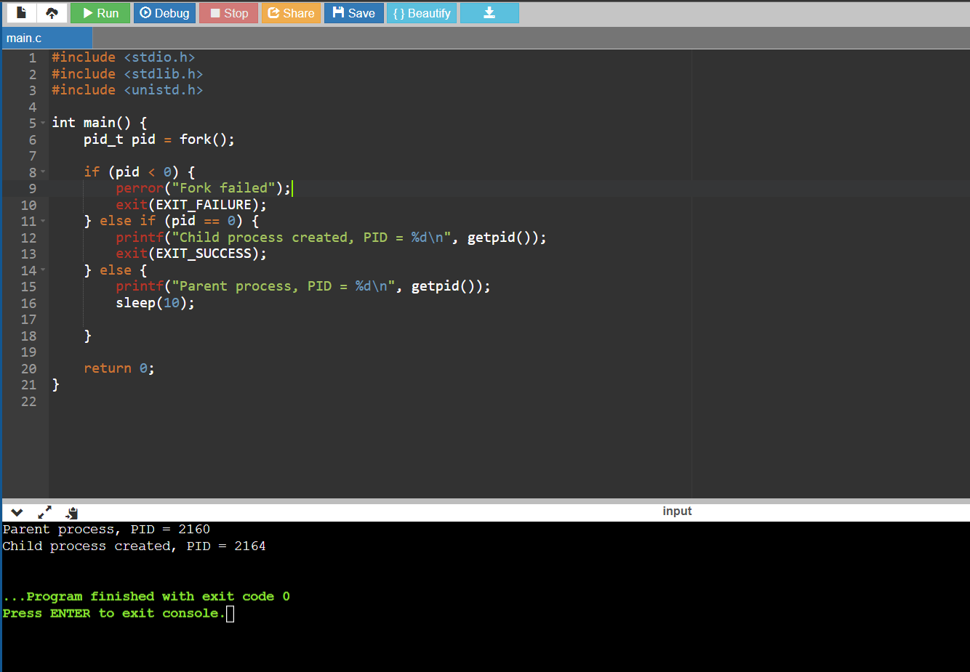

Q4. C program to implement the orphan process

Source Code:

#include <stdio.h>

#include <stdlib.h>

#include <unistd.h>

int main() {

pid_t pid = fork();

if (pid < 0) {

perror("Fork failed");

exit(EXIT_FAILURE);

}

printf("Child process created, PID = %d\n", getpid());

sleep(10);

printf("Child process exiting\n");

} else {

printf("Parent process, PID = %d\n", getpid());

printf("Parent process is terminating\n");

}

return 0;

}

Output:

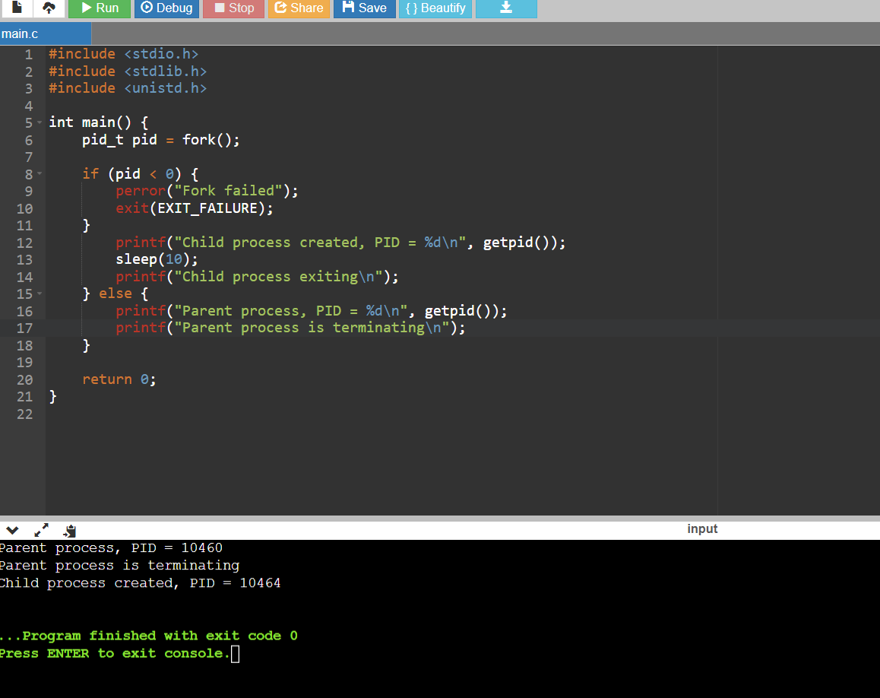

Q5. C program to implement FCFS CPU Scheduling Algorithm

Source Code:

#include <stdio.h>

struct Process {

int pid;

int arrival_time;

int burst_time;

};

void calculateWaitingTime(struct Process processes[], int n, int waiting_time[]) {

waiting_time[0] = 0;

for (int i = 1; i < n; i++) {

waiting_time[i] = waiting_time[i - 1] + processes[i - 1].burst_time;

}

}

void calculateTurnaroundTime(struct Process processes[], int n, int waiting_time[], int turnaround_time[]) {

for (int i = 0; i < n; i++) {

turnaround_time[i] = processes[i].burst_time + waiting_time[i];

}

}

void calculateAverageTimes(struct Process processes[], int n) {

int waiting_time[n], turnaround_time[n];

calculateWaitingTime(processes, n, waiting_time);

calculateTurnaroundTime(processes, n, waiting_time, turnaround_time);

float avg_waiting_time = 0, avg_turnaround_time = 0;

for (int i = 0; i < n; i++) {

avg_waiting_time += waiting_time[i];

avg_turnaround_time += turnaround_time[i];

}

avg_waiting_time /= n;

avg_turnaround_time /= n;

printf("Process\tBurst Time\tWaiting Time\tTurnaround Time\n");

for (int i = 0; i < n; i++) {

printf("%d\t%d\t\t%d\t\t%d\n", processes[i].pid, processes[i].burst_time, waiting_time[i], turnaround_time[i]);

}

printf("Average Waiting Time: %.2f\n", avg_waiting_time);

printf("Average Turnaround Time: %.2f\n", avg_turnaround_time);

}

int main() {

int n;

printf("Enter the number of processes: ");

scanf("%d", &n);

struct Process processes[n];

for (int i = 0; i < n; i++) {

processes[i].pid = i + 1;

printf("Enter arrival time for process %d: ", i + 1);

processes[i].pid = i + 1;

printf("Enter arrival time for process %d: ", i + 1);

scanf("%d", &processes[i].arrival_time);

printf("Enter burst time for process %d: ", i + 1);

scanf("%d", &processes[i].burst_time);

}

for (int i = 0; i < n - 1; i++) {

for (int j = 0; j < n - i - 1; j++) {

if (processes[j].arrival_time > processes[j + 1].arrival_time) {

struct Process temp = processes[j];

processes[j] = processes[j + 1];

processes[j + 1] = temp;

}

}

}

calculateAverageTimes(processes, n);

return 0;

}

Output:

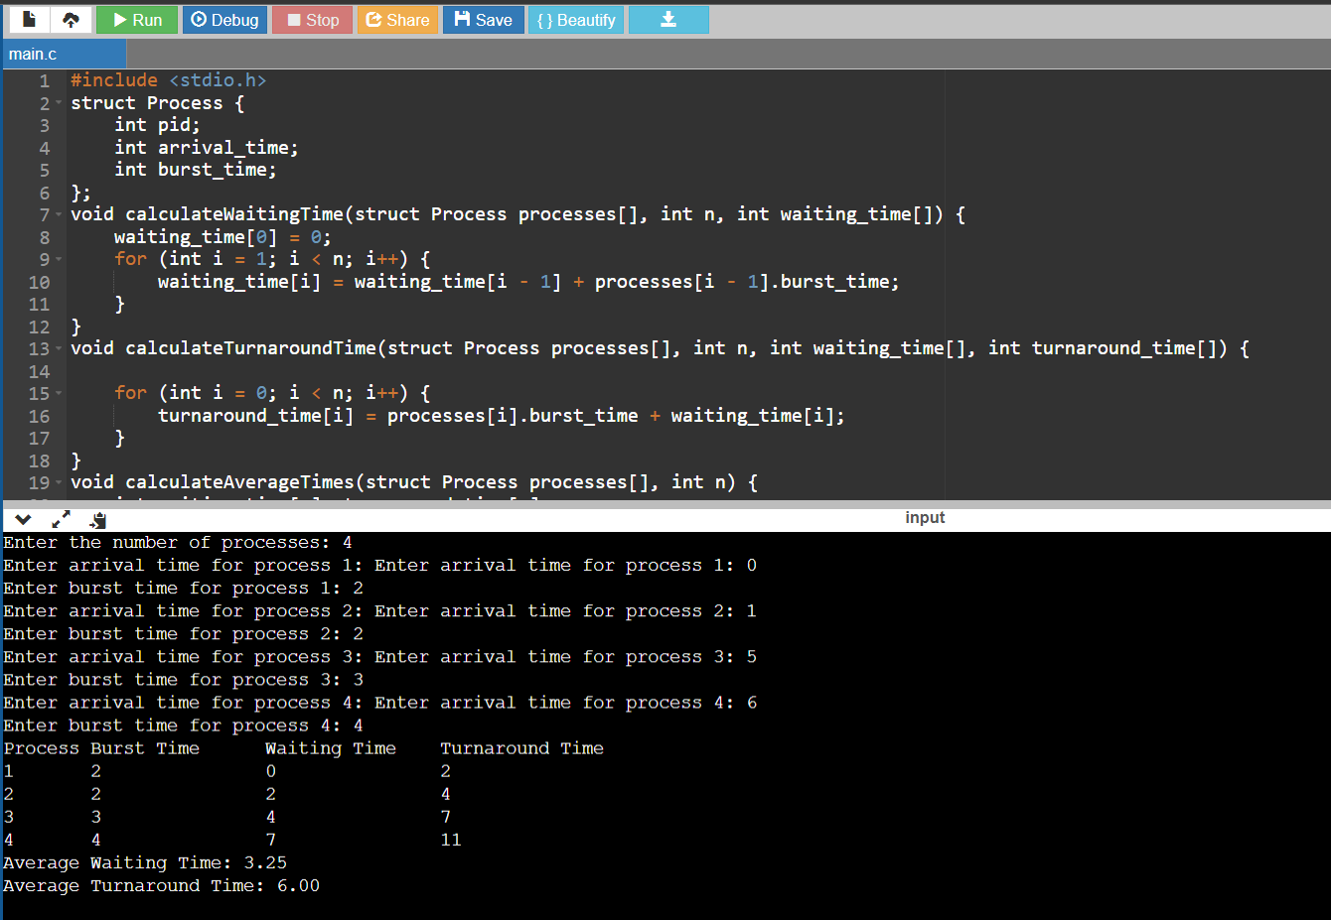

Q6. C program to implement SRTF CPU Scheduling Algorithm

Source Code:

#include <stdio.h>

#include <stdbool.h>

#include <limits.h>

#define MAX_PROCESSES 10

typedef struct {

int pid; // Process ID

int burst_time; // Burst time

int remaining_time; // Remaining burst time

} Process;

void srtf_schedule(Process processes[], int n) {

int current_time = 0;

int completed = 0;

int shortest = INT_MAX;

int shortest_index = -1;

printf("SRTF Schedule:\n");

printf("Time\tProcess\n");

while (completed < n) {

shortest = INT_MAX;

shortest_index = -1;

for (int i = 0; i < n; i++) {

if (processes[i].remaining_time > 0 && processes[i].remaining_time < shortest && processes[i].burst_time > 0 && processes[i].pid != -1) {

shortest = processes[i].remaining_time;

shortest_index = i;

}

}

if (shortest_index == -1) {

current_time++;

continue;

}

processes[shortest_index].remaining_time--;

current_time++;

if (processes[shortest_index].remaining_time == 0) {

printf("%d-%d\tP%d\n", current_time - 1, current_time, processes[shortest_index].pid);

completed++;

processes[shortest_index].pid = -1;

}

}

}

int main() {

int n;

printf("Enter the number of processes: ");

scanf("%d", &n);

if (n > MAX_PROCESSES || n <= 0) {

printf("Invalid number of processes. Maximum allowed: %d\n", MAX_PROCESSES);

return 1;

}

Process processes[MAX_PROCESSES];

printf("Enter burst times for each process:\n");

for (int i = 0; i < n; i++) {

processes[i].pid = i + 1;

printf("Burst time for P%d: ", i + 1);

scanf("%d", &processes[i].burst_time);

processes[i].remaining_time = processes[i].burst_time;

}

srtf_schedule(processes, n);

return 0;

}

Output:

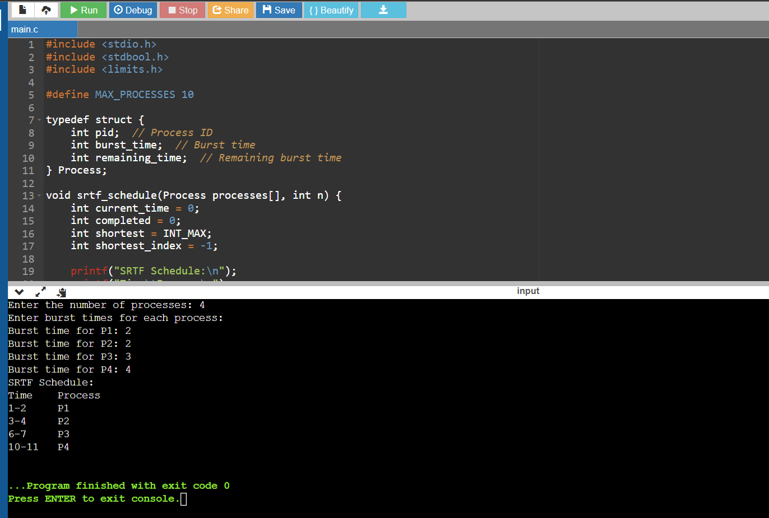

Q7. C program to implement Round Robin CPU Scheduling Algorithm

Source Code:

#include <stdio.h>

struct Process {

int pid;

int burst_time;

int remaining_time;

};

void roundRobin(struct Process processes[], int n, int quantum) {

int remaining_processes = n;

int current_time = 0;

for (int i = 0; i < n; i++) {

processes[i].remaining_time = processes[i].burst_time;

}

while (remaining_processes > 0) {

for (int i = 0; i < n; i++) {

if (processes[i].remaining_time <= 0) {

continue;

}

int execute_time = (processes[i].remaining_time < quantum) ? processes[i].remaining_time : quantum;

processes[i].remaining_time -= execute_time;

current_time += execute_time;

printf("Time %d: Process %d is running for %d units.\n", current_time, processes[i].pid, execute_time);

if (processes[i].remaining_time <= 0) {

remaining_processes--;

int turnaround_time = current_time;

printf("Time %d: Process %d completed. Turnaround time = %d\n", current_time, processes[i].pid, turnaround_time);

}

}

}

}

int main() {

int n, quantum;

printf("Enter the number of processes: ");

scanf("%d", &n);

printf("Enter the time quantum: ");

scanf("%d", &quantum);

struct Process processes[n];

for (int i = 0; i < n; i++) {

processes[i].pid = i + 1;

printf("Enter burst time for process %d: ", i + 1);

scanf("%d", &processes[i].burst_time);

}

roundRobin(processes, n, quantum);

return 0;

}

Output:

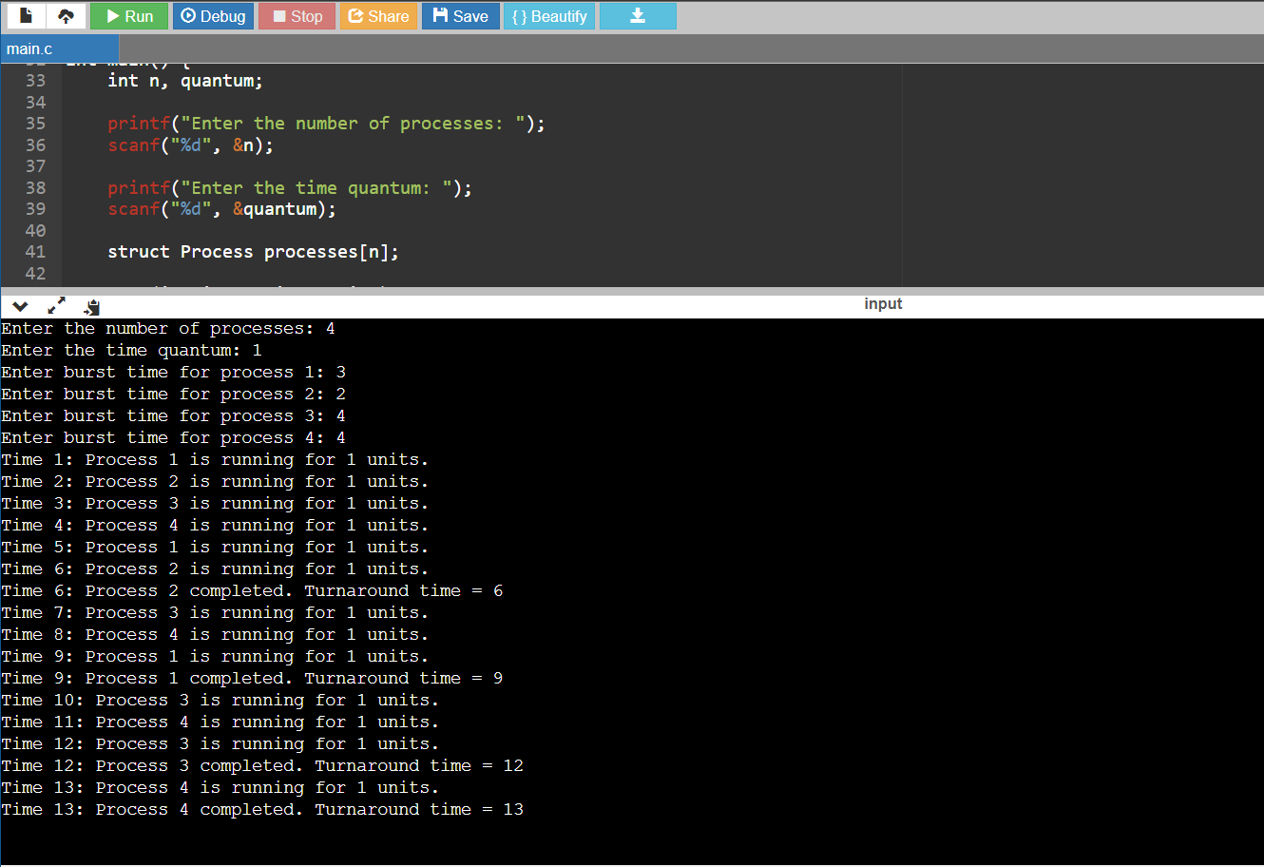

1.Write a c code for non-preemptive Shortest Job First (SJF) scheduling is a scheduling algorithm

Source Code:

#include <stdio.h>

#define MAX_PROCESSES 10

typedef struct {

int process_id;

int burst_time;

} Process;

void swap(Process *a, Process *b) {

Process temp = *a;

*a = *b;

*b = temp;

}

void sjf_nonpreemptive(Process processes[], int n) {

int waiting_time[MAX_PROCESSES], turnaround_time[MAX_PROCESSES];

float average_waiting_time = 0, average_turnaround_time = 0;

for (int i = 0; i < n - 1; i++) {

for (int j = 0; j < n - i - 1; j++) {

if (processes[j].burst_time > processes[j + 1].burst_time) {

swap(&processes[j], &processes[j + 1]);

}

}

}

waiting_time[0] = 0;

turnaround_time[0] = processes[0].burst_time;

for (int i = 1; i < n; i++) {

waiting_time[i] = waiting_time[i - 1] + processes[i - 1].burst_time;

turnaround_time[i] = waiting_time[i] + processes[i].burst_time;

average_waiting_time += waiting_time[i];

average_turnaround_time += turnaround_time[i];

}

average_waiting_time /= n;

average_turnaround_time /= n;

printf("Process\tBurst Time\tWaiting Time\tTurnaround Time\n");

for (int i = 0; i < n; i++) {

printf("%d\t%d\t\t%d\t\t%d\n", processes[i].process_id, processes[i].burst_time,

waiting_time[i], turnaround_time[i]);

}

printf("\nAverage Waiting Time: %.2f\n", average_waiting_time);

printf("Average Turnaround Time: %.2f\n", average_turnaround_time);

}

int main() {

int n;

Process processes[MAX_PROCESSES];

printf("Enter the number of processes: ");

scanf("%d", &n);

printf("Enter burst time for each process:\n");

for (int i = 0; i < n; i++) {

processes[i].process_id = i + 1;

printf("Burst time for process %d: ", i + 1);

scanf("%d", &processes[i].burst_time);

}

sjf_nonpreemptive(processes, n);

return 0;

}

Output:

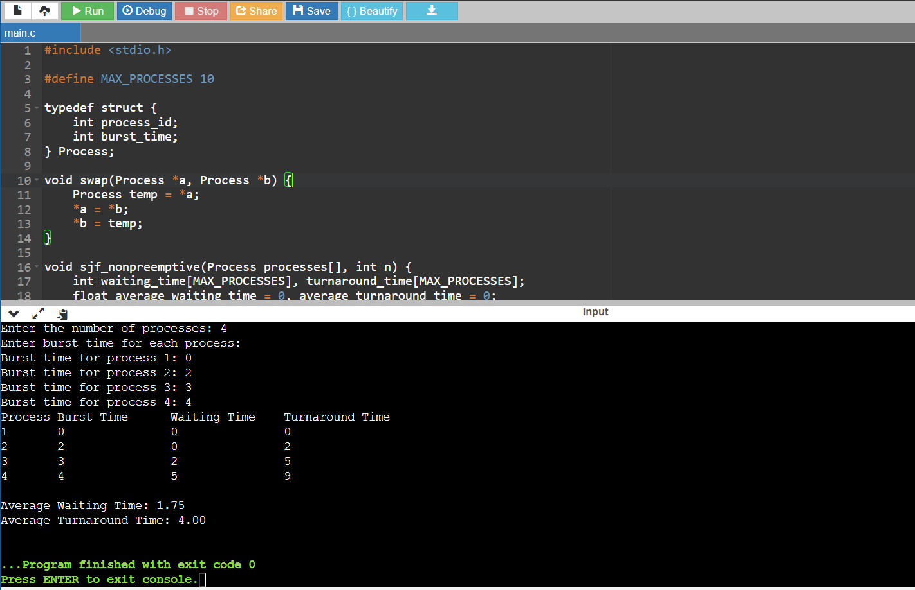

2. Write a c code for Non-preemptive Priority Scheduling is a scheduling algorithm

Source Code:

#include <stdio.h>

#define MAX_PROCESSES 10

typedef struct {

int process_id;

int priority;

int burst_time;

} Process;

void swap(Process *a, Process *b) {

Process temp = *a;

*a = *b;

*b = temp;

}

void priority_nonpreemptive(Process processes[], int n) {

int waiting_time[MAX_PROCESSES], turnaround_time[MAX_PROCESSES];

float average_waiting_time = 0, average_turnaround_time = 0;

for (int i = 0; i < n - 1; i++) {

for (int j = 0; j < n - i - 1; j++) {

if (processes[j].priority < processes[j + 1].priority) {

swap(&processes[j], &processes[j + 1]);

}

}

}

waiting_time[0] = 0;

turnaround_time[0] = processes[0].burst_time;

for (int i = 1; i < n; i++) {

waiting_time[i] = waiting_time[i - 1] + processes[i - 1].burst_time;

turnaround_time[i] = waiting_time[i] + processes[i].burst_time;

average_waiting_time += waiting_time[i];

average_turnaround_time += turnaround_time[i];

}

average_waiting_time /= n;

average_turnaround_time /= n;

// Display the schedule and timing information

printf("Process\tPriority\tBurst Time\tWaiting Time\tTurnaround Time\n");

for (int i = 0; i < n; i++) {

printf("%d\t%d\t\t%d\t\t%d\t\t%d\n", processes[i].process_id, processes[i].priority,

processes[i].burst_time, waiting_time[i], turnaround_time[i]);

}

printf("\nAverage Waiting Time: %.2f\n", average_waiting_time);

printf("Average Turnaround Time: %.2f\n", average_turnaround_time);

}

int main() {

int n;

Process processes[MAX_PROCESSES];

printf("Enter the number of processes: ");

scanf("%d", &n);

printf("Enter priority and burst time for each process:\n");

for (int i = 0; i < n; i++) {

processes[i].process_id = i + 1;

printf("Priority for process %d: ", i + 1);

scanf("%d", &processes[i].priority);

printf("Burst time for process %d: ", i + 1);

scanf("%d", &processes[i].burst_time);

}

priority_nonpreemptive(processes, n);

return 0;

}

Output:

